WEST WALES INTEGRATED PROGRAMME DELIVERY BOARD | Item 6b

7 APRIL 2017
Appendix 3
Integrated Autism Service

Purpose
- To advise the Board on requirements regarding the establishment of an Integrated Autism Service in the region, which will be funded through the Integrated Care Fund (ICF).
Background
- A National Autism Strategy for Wales was launched by Welsh Government in 2008. As part of its roll-out, extensive consultation was undertaken during 2015 to ascertain issues and concerns of a range of stakeholders and this identified a series of gaps in current services across Wales. Key gaps identified through the consultation, a number of which are being addressed through an interim delivery plan, were as follows:
- Support for emotional / behavioural issues
- Support for ASD specific issues and life skills
- Access to social and leisure opportunities within own community
In addition to these lack of supportive ASD-aware education provision was a frequently reported issue for children and lack of support in relation to employment for adults.
- Parents and carers also reported unmet support needs. These were broadly consistent for children and adults, with the most frequently reported issues being:

- Inability to access advice in a timely manner
- Lack of social activities leading to social isolation
- Lack of training, information and support to manage problems and behaviours

- Three core themes were identified as a result of the consultation in relation to current ASD provision in Wales:
- Staff within generic and community services lack the skills and knowledge to support individuals with ASD
- Eligibility criteria for tier 2 and 3 services mean that individuals with higher functioning ASD (and their carers) fall into gaps between mental health and learning disability services and so cannot access emotional, behavioural, low level mental health and life skills support.
- Existing generic community support and services need to be adapted in order to meet specific needs of individuals with ASD

National Integrated Autism Service

- In response to the consultation, Welsh Ministers have agreed to the implementation of a National Autism Service (NIAS) for Wales, based on the following principles:

- The service must provide the same model of support across Wales, which is supported by NICE guidelines.
- There should be consistent diagnostic pathways for children and adults, and routes to these should be communicated.
- All partners must be involved in supporting the service – senior management buy-in must be secured.
- There should be robust infrastructure with clear governance arrangements.
- The service must include / link to existing autism provision where available (e.g. neurodevelopmental teams, retained CMS projects, local authority ASD leads etc).
- There will need to be planned roll out and national implementation oversight and support
- The service must be supported with the resources required to support, enable and train others – to be delivered by the refreshed ASD Strategic
- Action Plan.
- A sustainability plan must be developed as part of the implementation process to ensure the service is continued after year three.
- There must be a planned independent evaluation approach which supports the implementation of the service from its inception.
- There must be continued awareness raising and training for other non-specialist services and community provision

- The core aim of the NIAS is to guarantee residents across Wales with high quality, consistent autism services. The service will be implemented incrementally across Wales, with funding from the ICF. Funding will be available to regions over a 4 year period. Regional Partnership Boards will be accountable for development and delivery of the NIAS within their areas, thus ensuring an integrated, partnership approach across local government, health and the third sector. The initial phase of implementation will involve establishing regional governance structures, developing an implementation plan and recruiting staff for the service.
- Locally the NIAS will need to be delivered through an integrated model with a multi-disciplinary team comprising as a minimum the following:
1 x Clinical psychologist
0.5 wte Speech and Language Therapist
0.5 wte Occupational Therapist
2 x Specialist Practitioners
1 x Therapist
1 x Admin
1 x Support Worker per LA area
- The service will be expected to complement existing structures as set out below.

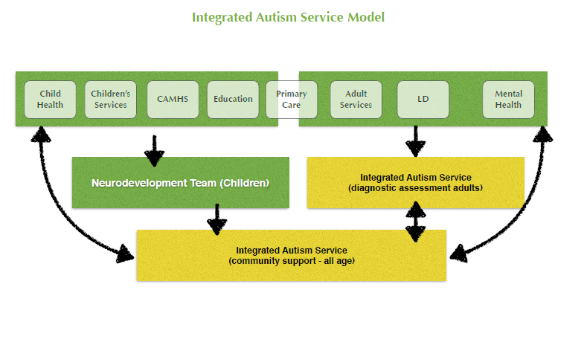
- A multi-professional regional strategy group will need to be established, reporting to the Regional Partnership Board, to oversee pathway development and implementation of the service. Implementing the NIAS in West Wales. Links will need to be established between the strategy board and existing local stakeholder groups to ensure effective input from users, carers and others. Strategic support and advice will be provided by the National ASD Lead and Development Team, which is funded by Welsh Government and hosted by the WLGA. A regional officer has been appointed to the Development Team to work with the ASD National Lead in supporting implementation in the West Wales and Western Bay regions.
- The following chart sets out the national infrastructure for the NIAS.

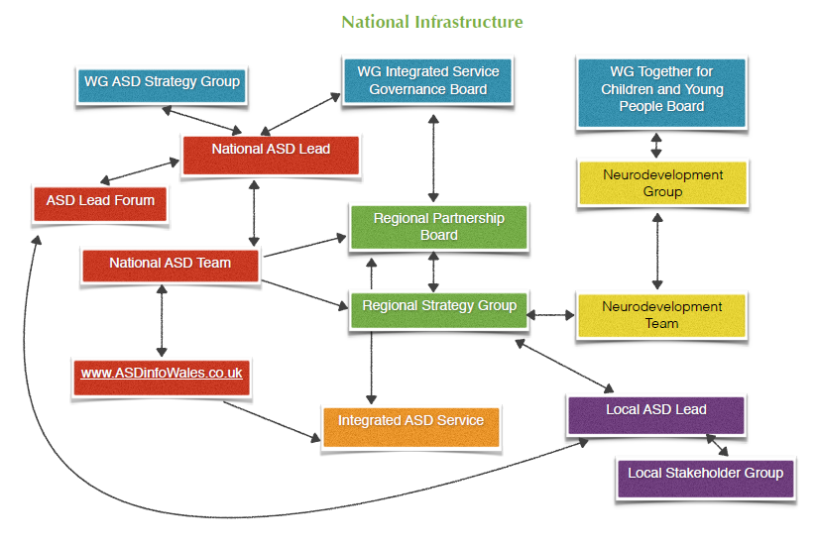

Implementation of the NIAS in West Wales
- Welsh Government has confirmed first year funding to support the implementation of the NIAS in West Wales through its 2017-18 ICF allocation. The amount allocated is £0.298M.
- An initial multi-professional meeting was held on 21 March, attended by the National ASD Lead and regional officer, to start planning for implementation. It was agreed that arrangements should be established as soon as practicable to start the implementation process.
- The expectation will be for the establishment of integrated arrangements in West Wales as part of the NIAS service by July 2018. Resources available in the current year through ICF can be used to secure programme management capacity for the first phase of implementation.
Recommendations

That the Board:
- Notes the requirements for implementation of the NIAS as set out in this report
- Mandates the establishment of a regional strategy group a matter of urgency to consider the requirements and plan for the initial phase of implementation, beginning with an outline programme and resource plan
- Nominates a senior representative (Head of Service or equivalent from local authority children’s and adults’ services, the UHB and third sector), to sit on the strategy group and provide strategic leadership for implementation
- Nominates additional representatives for the strategy group

